**Connection**

1. The device can be powered via the two pins using any battery 7 – 12V or USB. Power on the device and launch ArduinoGUI.

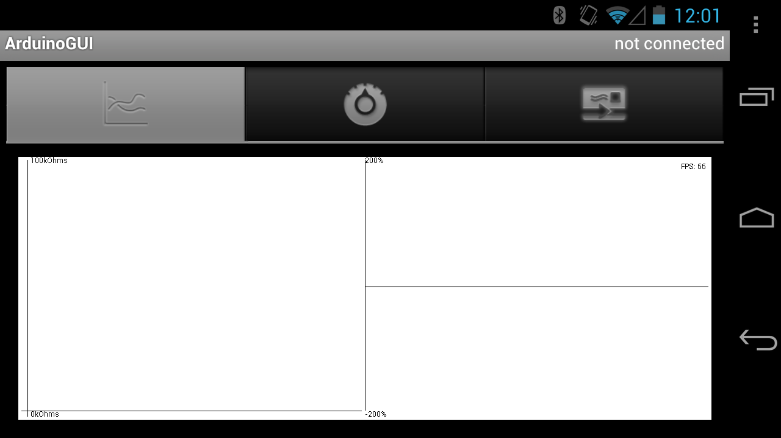

1. Press the menu button on the phone and select “Connect Device”

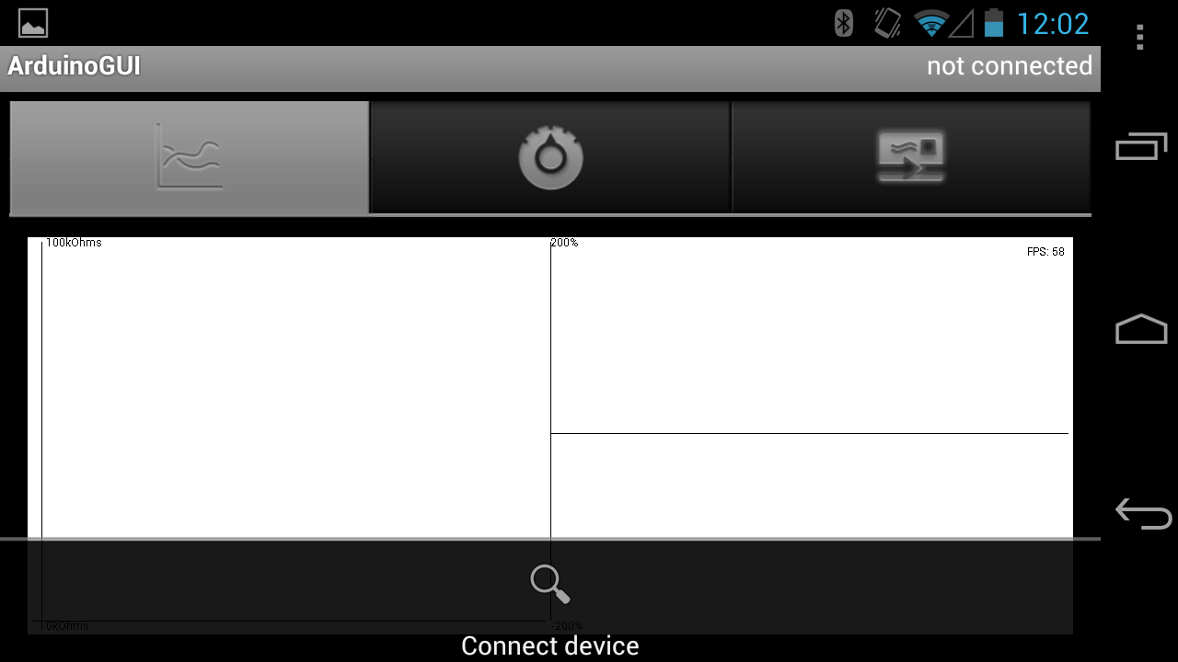

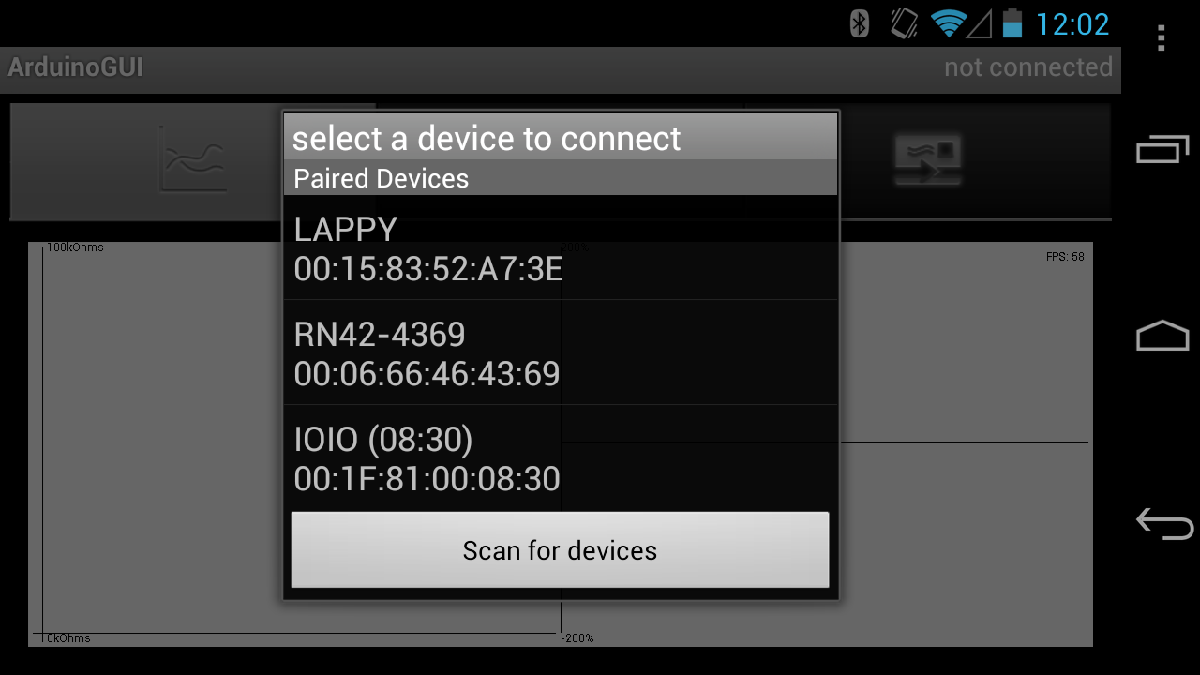

1. If not already paired, choose scan for devices, then choose the device from the list. The pairing PIN is **1234**. It can also be paired from the Bluetooth settings of the phone

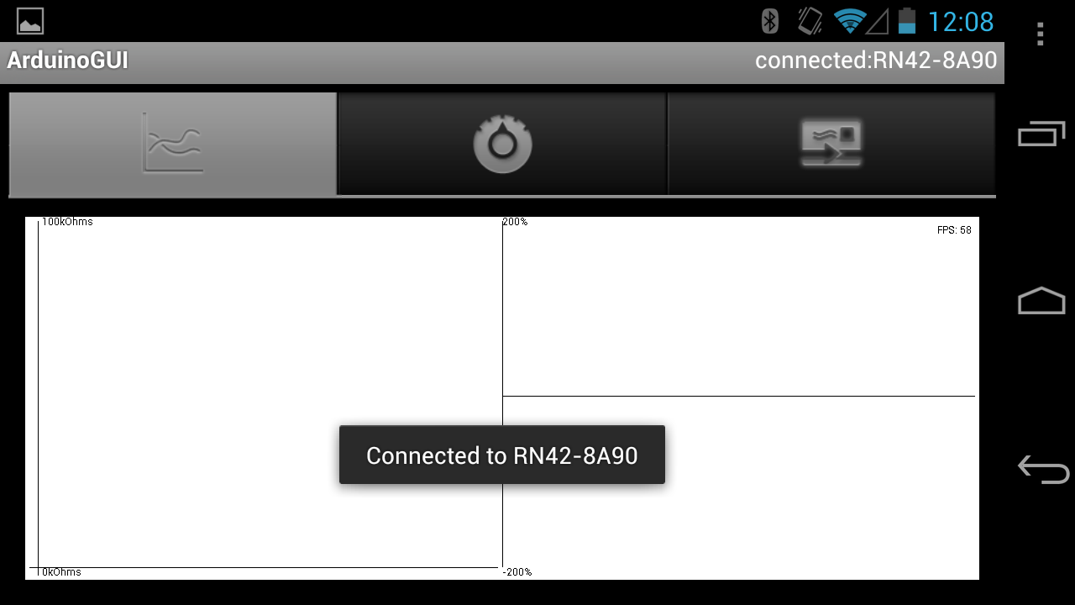

1. When connected a popup will notify you and in the top right corner it will state the connection status.

**Starting Polling**

1. Select the settings tab at the top

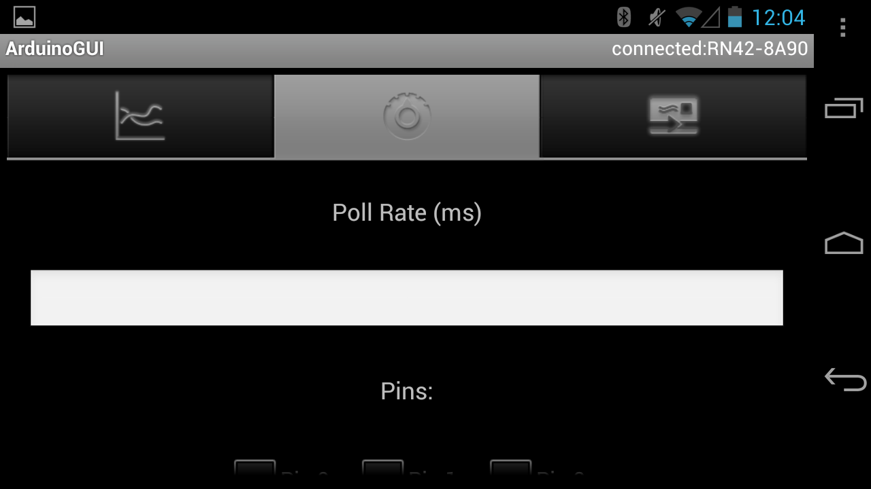

1. Type in a value for the polling rate in milliseconds, minimum is 100, and will default to this if an invalid value or if nothing is entered.

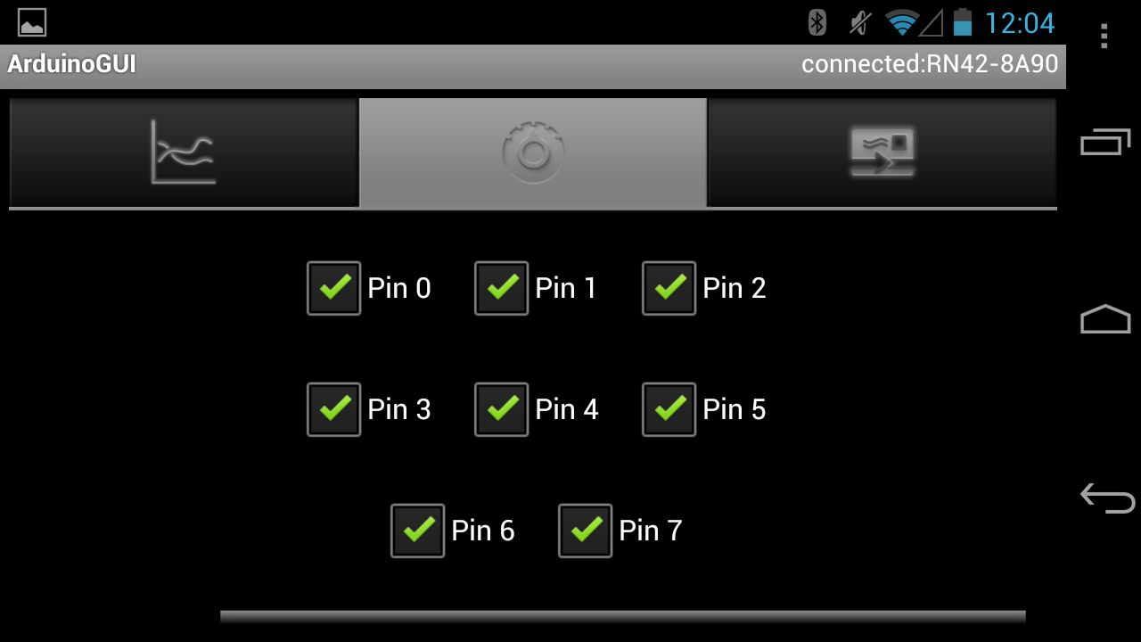

1. Choose the pins you want to poll for data

|  |  |  |  |
| --- | --- | --- | --- |
| Pin Number | Description | Pin Number | Description |
| 0 | Nano Sensor 1 | 4 | N/C |
| 1 | Nano Sensor 2 | 5 | TGS825 Sensor |
| 2 | Nano Sensor 3 | 6 | Humidity Sensor |
| 3 | Nano Sensor 4 | 7 | Temp Sensor |

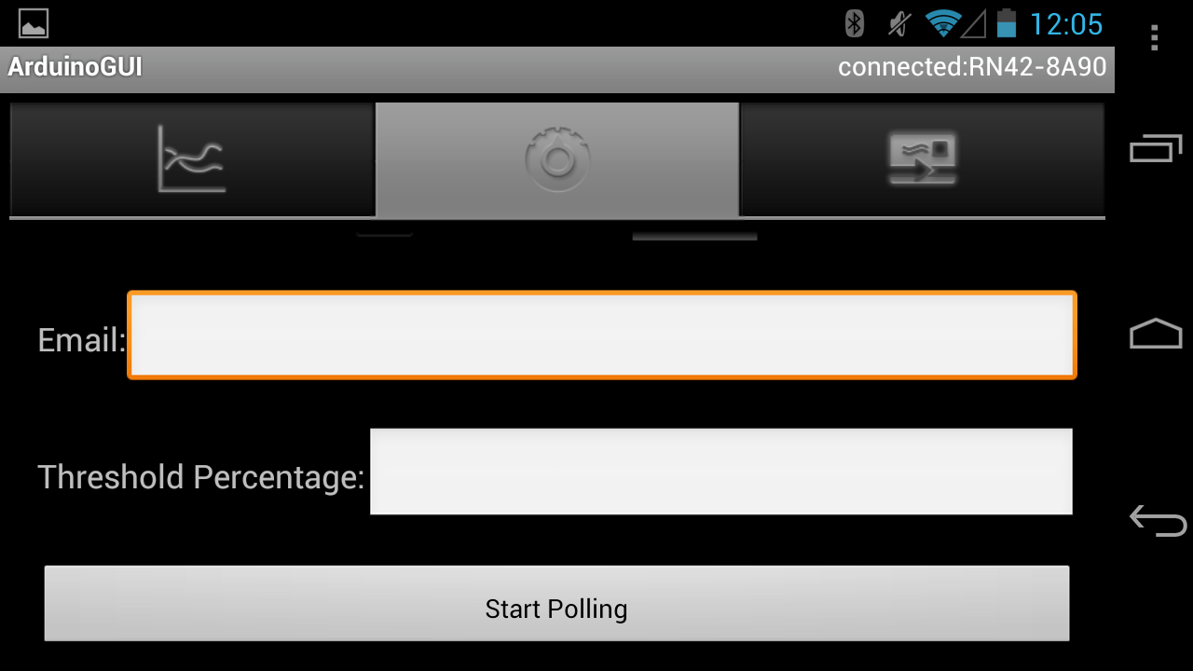

1. Scroll to the bottom and press start polling. Press the graph tab at the top to return to the graph screen. When done press the button again to stop polling

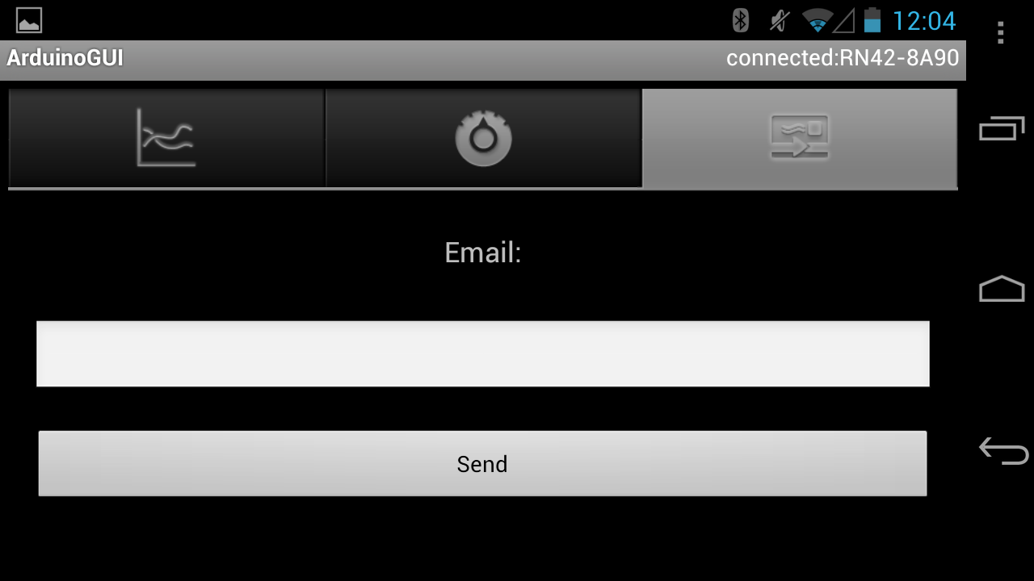

1. When done you can e-mail the data gathered to yourself. The files are attached as raw text files.
   1. They are also stored locally at /sdcard/ArduinoGUI/[month]_[day]_[hour]_[millis]p[pin].txt

**E.g. 10_2_12_5_80p1.txt**

GPS Data is saved at /sdcard/ArduinoGUI/[month]_[day]_[hour]_[millis]GPSData

**E.g.** **10_2_12_5_80GPSData**

**View Control**

1. Touch the screen to change to a different sensor view

|  |  |
| --- | --- |
| Screen | Description |
| 1 | Nano Sensors |
| 2 | TGS825 Sensor |
| 3 | Humidity |
| 4 | Temperature |
| 5 | GPS |

**Nano Sensors**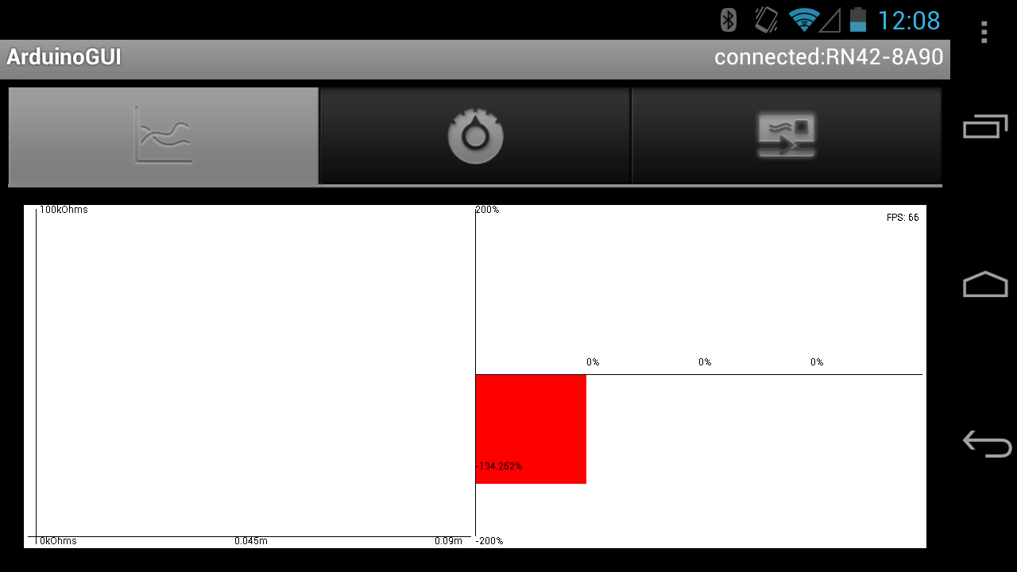

**TGS825 Sensor**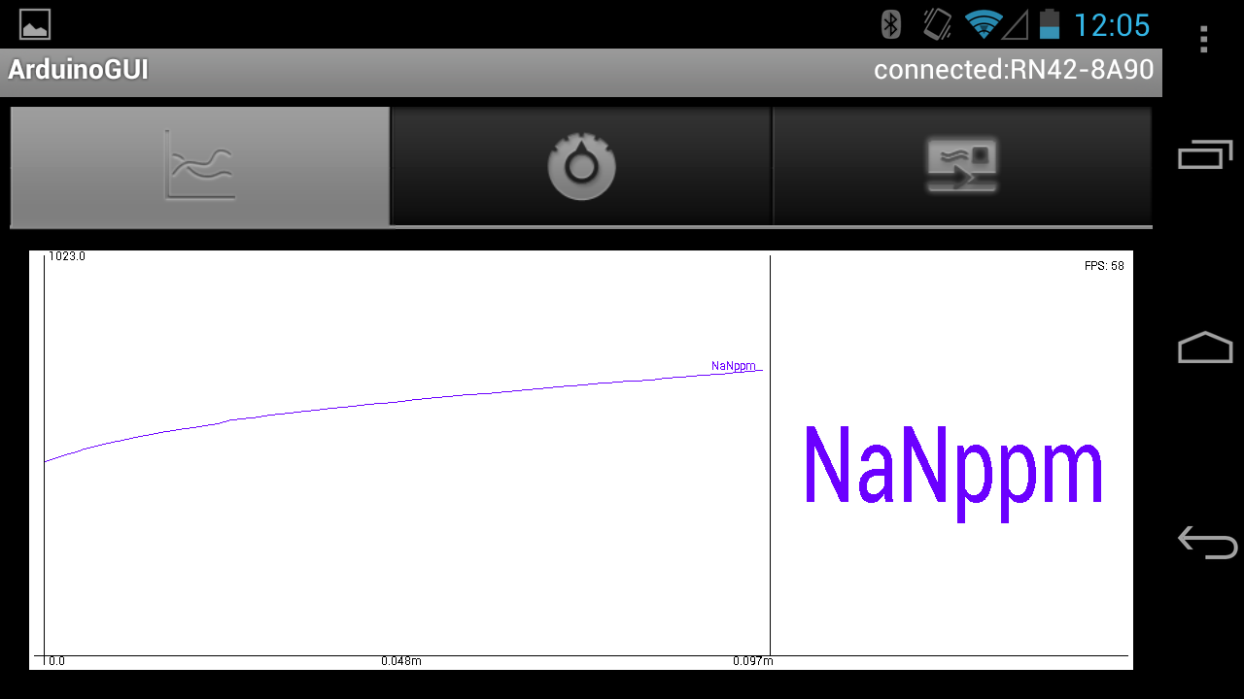

**Humidity Sensor**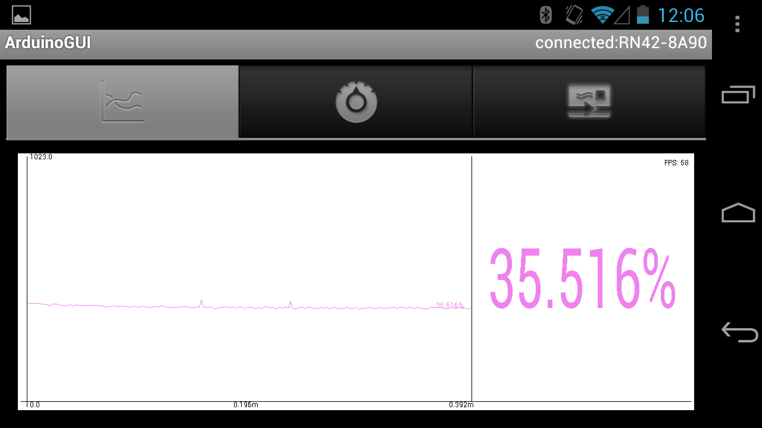

**Temperature Sensor**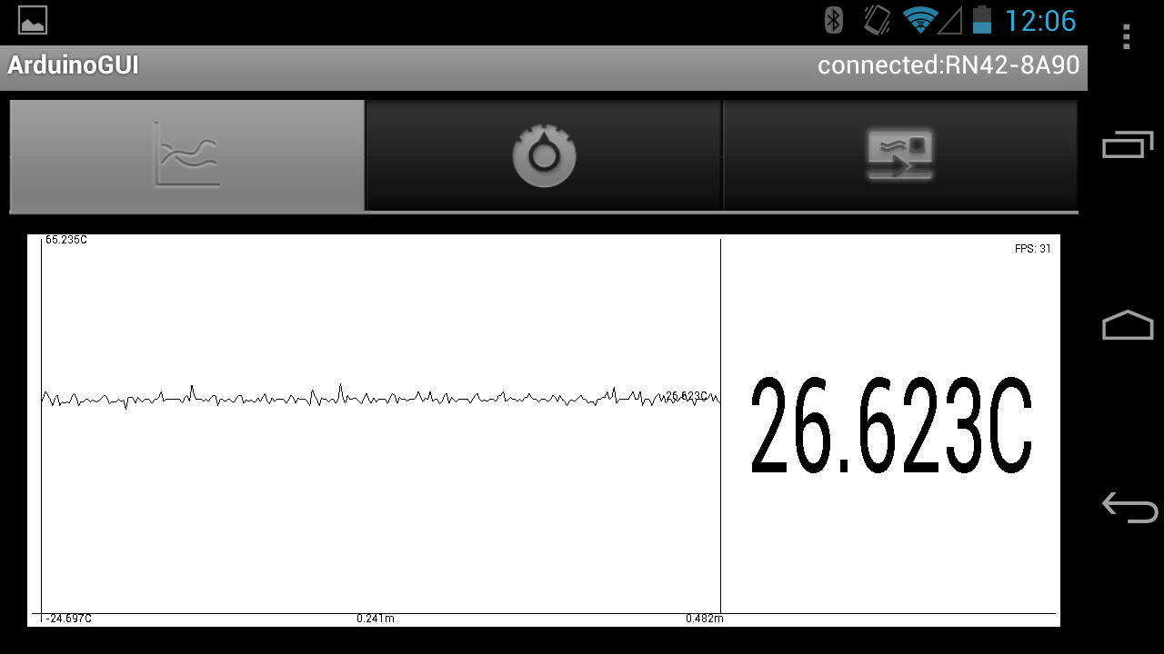

**GPS Coordinates**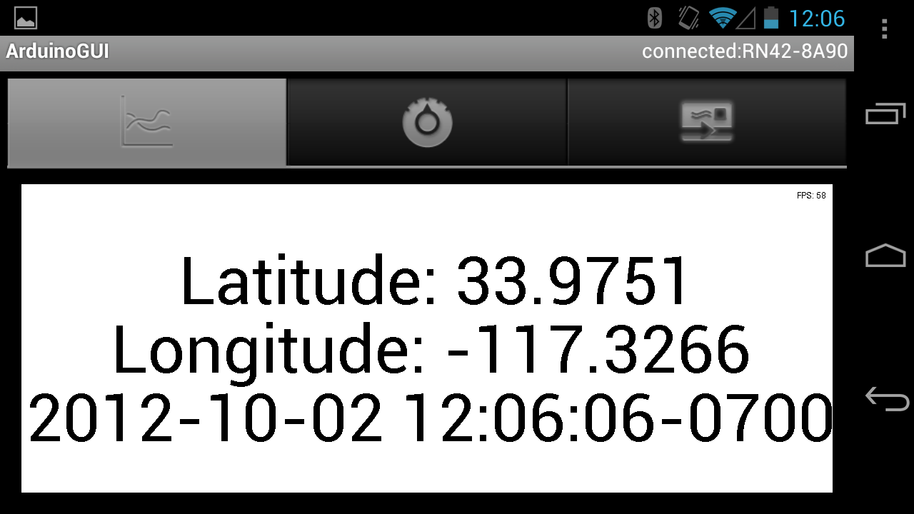



1. Unchecking a pin while it is polling will hide that particular pin from the graph allowing you to view a specific nano sensor

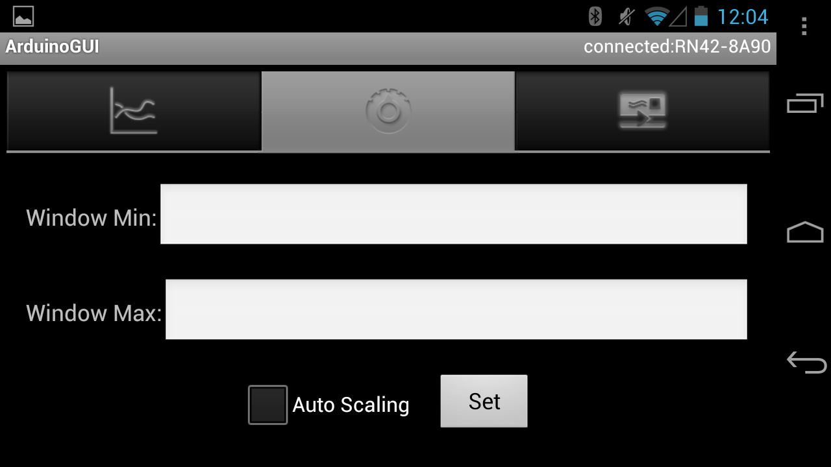

1. Window max and min values set the range of resistances for the nano sensor view which ranges from 0 – 100kOhms.
   1. **Valid values for window min and max:** 0 < Window Min < Window Max < 1023
   2. Auto scaling, if checked will attempt to fit the max and min that has been read so far for the non-hidden nano sensor pins